Media Contact: Insert Name
FOR IMMEDIATE RELEASE
INSERT PHONE
INSERT EMAIL

SPECIAL PREVIEW SCREENING OF “THE UNAFRAID” COMES TO [CITY NAME]

New PBS Documentary on DACA Students looks at the Challenges Facing Undocumented Immigrant Youth in the U.S. Today
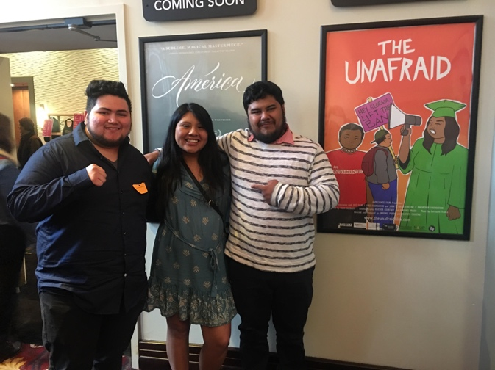
CITY, DATE – In advance of the film’s PBS national broadcast premiere this fall, organization Name(s) will host a free preview community screening of The Unafraid, an award-winning feature length documentary that follows the personal lives of three “DACAmented” students in Georgia, a state that has banned undocumented and DACA students from attending their top five public universities and disqualifies them from receiving in-state tuition at any other public college. The community is invited to participate in this free screening event on date at time at the location. The screening will be followed by a panel discussion with local experts and leaders working on immigrant issues in our community. Tickets are available at [ticketing/registration info].

Shot over a period of four years, The Unafraid takes an intimate look at the lives of Alejandro, Silvia and Aldo and the obstacles they face as they navigate activism, chasing their dream of education, and their and their families’ personal struggles and triumphs. The Unafraid is a unique portrait of growing up both American and undocumented in the United States.

[Insert a quote by your organizational leader on why you wanted to host this event/the value it will provide the community]

​The New York Times writes of the three youth featured in The Unafraid, "​Their tenacity is inspiring; their struggles disheartening." The film has received high praise from audiences and judges on the 2018-19 festival circuit, featured as the Closing Night Film at the Human Rights Watch Film Festival and winning the Kathleen Byran Edward Human Rights Award at their premiere at the Full Frame Documentary Film Festival. At a time when migrant children are being separated from their families and held in squalid conditions in detention centers along the U.S.-Mexico border, this screening event will provide a space for community members to have open, honest, and informed discussion about immigration and the issues raised by the film.

This event is free and open to the public, but an RSVP is required. Attendees should visit INSERT LINK for more information.

ABOUT HOST NAME
INSERT DESCRIPTION OF GROUP

For more info and to watch the trailer for The Unafraid, visit www.theunafraidfilm.com.

